Business Model Canvas – FloFie (C22-PS311)

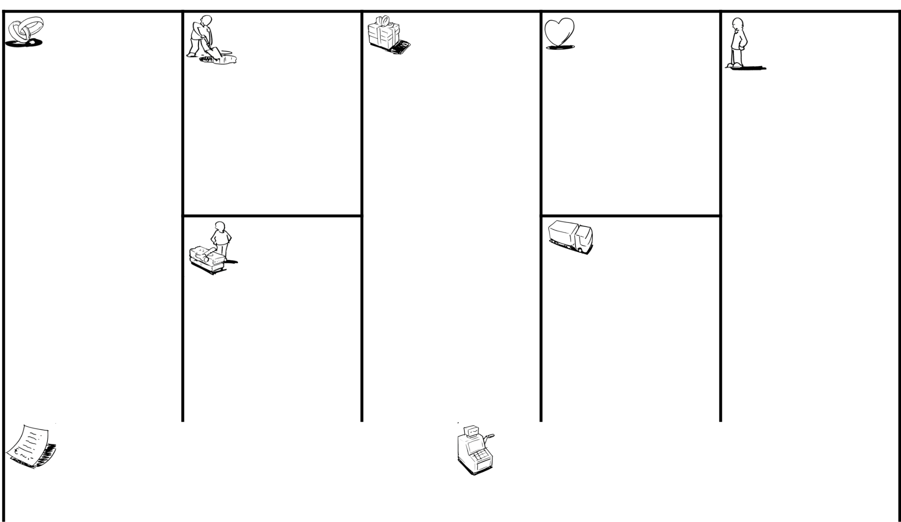

|  |  |  |  |  |
| --- | --- | --- | --- | --- |
| **Key Partners** | **Key Activities** | **Value Propositions** | **Customer** | **Customer Segments** |
|  |  |  | **Relationships** |  |

|  |  |
| --- | --- |
| **Key Resources** | **Channels** |

|  |  |
| --- | --- |
| **Cost Structure** | **Revenue Streams** |
|  |  |

|  |  |
| --- | --- |
| **Social & Environmental Cost** | **Social & Environmental Benefit** |
|  |  |



[http://www.businessmodelgeneration.com](http://www.businessmodelgeneration.com/)

Directions for completing the Canvas

